User Manual – Use Cases 14, 15, and 8

View Academic Record:

A student wishing to view their academic record and/or GPA may do so from the ‘Profile’ tab (See Figure 1).

*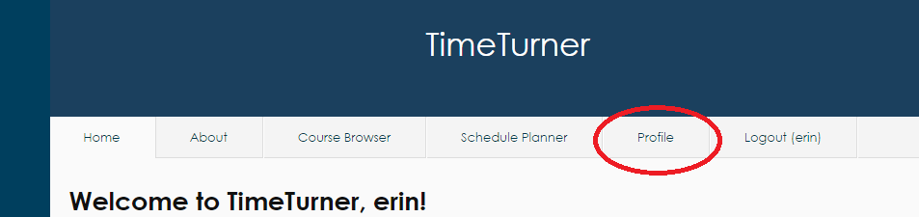*

*Figure 1. Profile Tab located second from right at the top of the screen*

Once on the ‘Profile’ page, the student may click on the ‘View Academic Record’ displayed at the far right of the page (see Figure 2). Clicking this link will result in the display of all classes that the student has completed, as well as their grades for each course, and their GPA.

*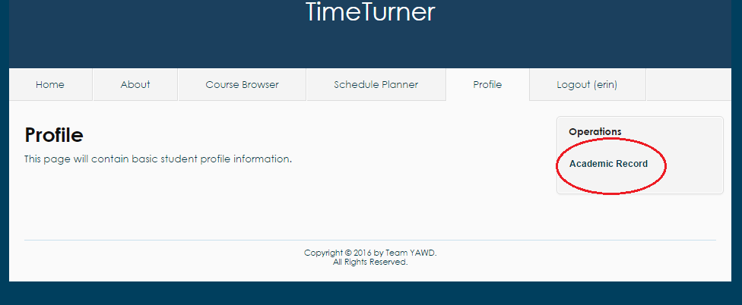*

*Figure 2. Academic Record link in ‘Operations’ on far right of ‘Profile’ screen*

Create Course:

An administrator may wish to create a course to add to the database of courses that students can take. In order to do so, the administrator must first click on the ‘Courses’ tab to find themselves on the courses database page (see Figure 3). From here, the administrator must click the ‘Create Course’ link located on the far right of the page; this action will display the course creation page (see Figure 4).

*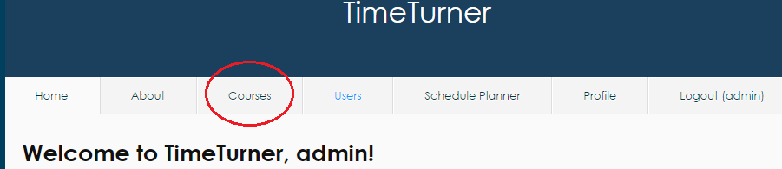*

*Figure 3. Courses tab on top of page when logged in as Administrator*

*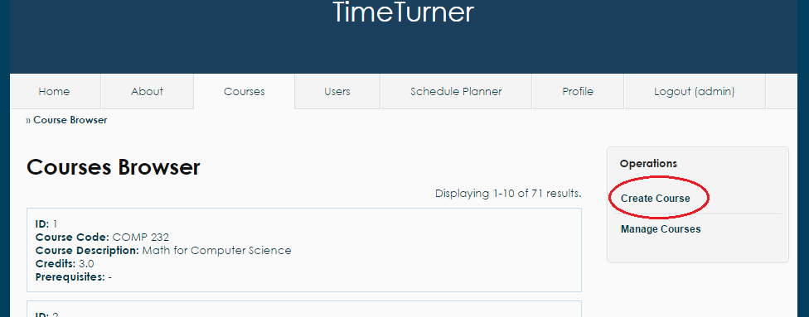*

*Figure 4. Create course link on far right of Course Browser page*

This page will ask for the course code, the course description, and the amount of credits awarded by the course (see Figure 5 for example input). Once the administrator enters the appropriate course information, the system will log such information in the database, and the course information for the newly created course will be displayed on screen, along with the course’s newly assigned ID.

*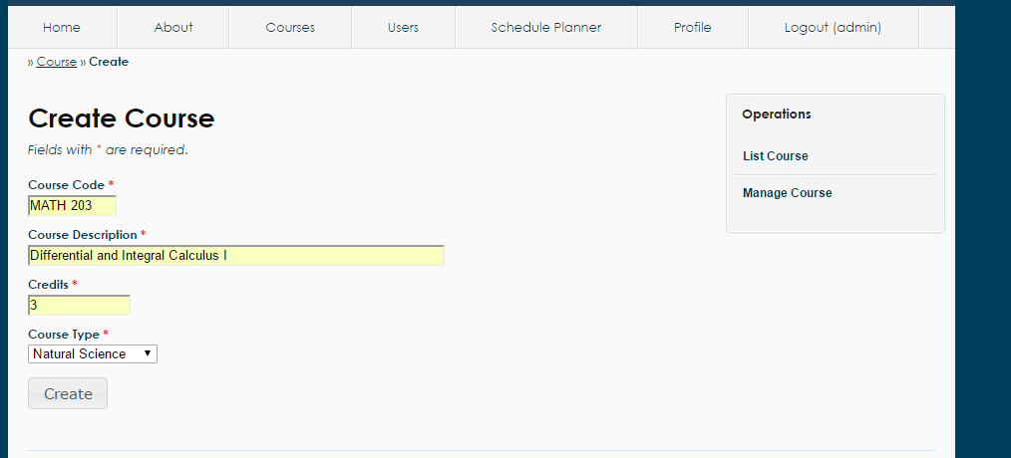*

*Figure 5. Sample input for Create Course functionality*

Browse Courses:

While logged in, the administrator may wish to view the database of courses in the system. To accomplish this, the administrator may simply click on the Courses tab; this will cause the list of all courses to be displayed on screen (see Figure 3). Courses are grouped by page, 10 to a page. If the administrator wishes to view more courses, he may scroll down to the bottom of the page and click on the desired page number.

While on the Courses tab, the administrator may navigate away by clicking the two links located in the ‘Operations’ box to the right of the page: Create Course and Manage Course. Clicking these links will bring the administrator to those respective pages where other activities and actions may be carried out.

If the administrator wishes to view the prerequisite information of a course, he may simply click on the name of the prerequisite to that course (see Figure 6). Clicking on the name of the prerequisite will display the course information of the prerequisite.

*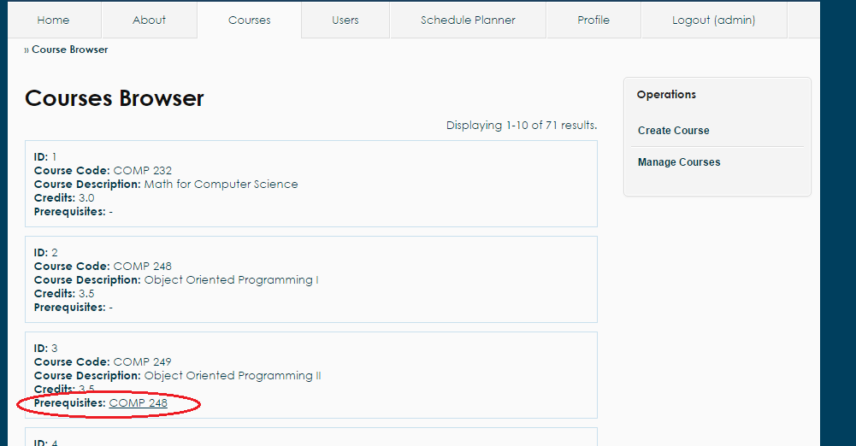*

*Figure 6. Prerequisites for each Course located in the course information box*